WEB API MODULE
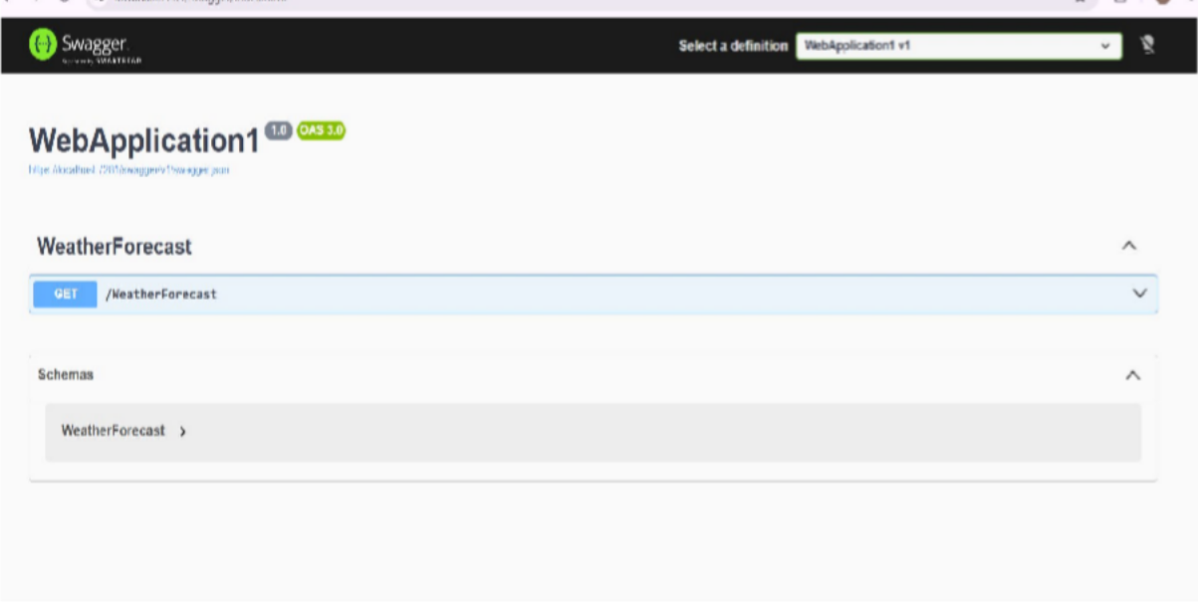

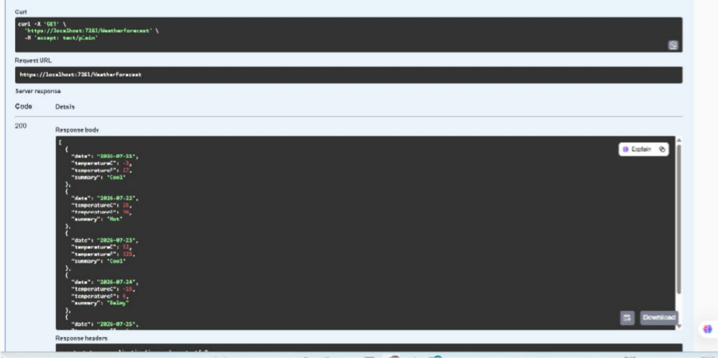

Employee:

WEB API MODULE
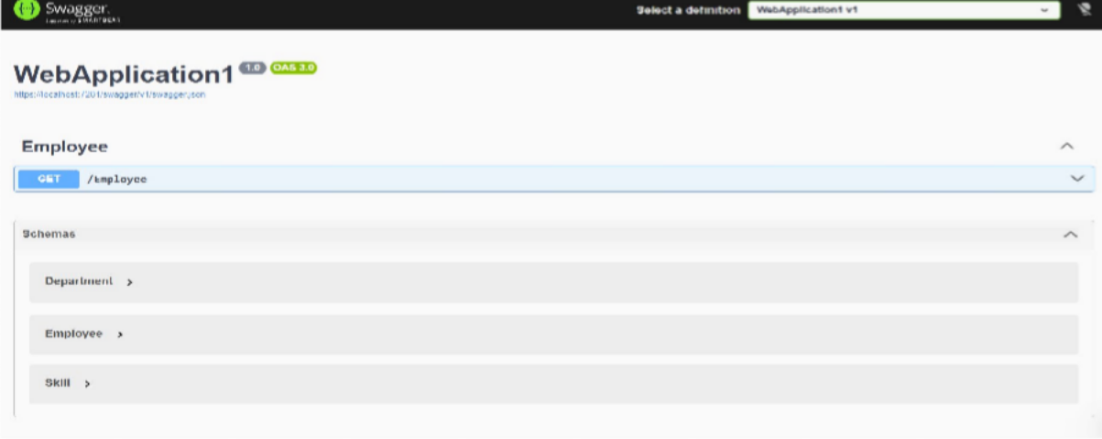
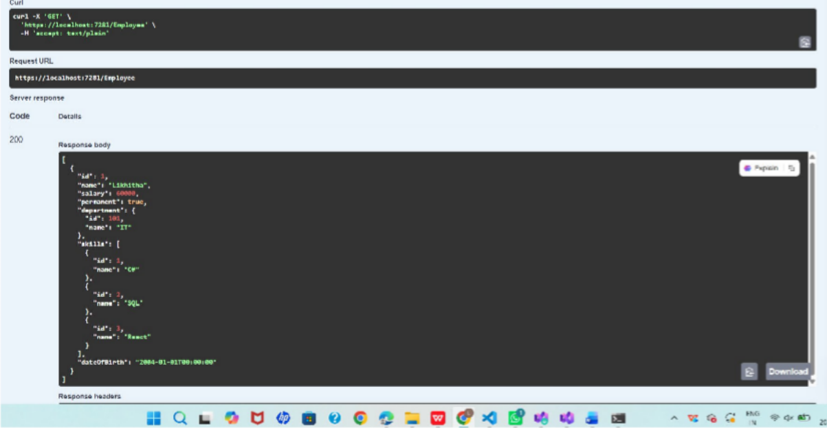

Implementationof get post put:

WEB API MODULE
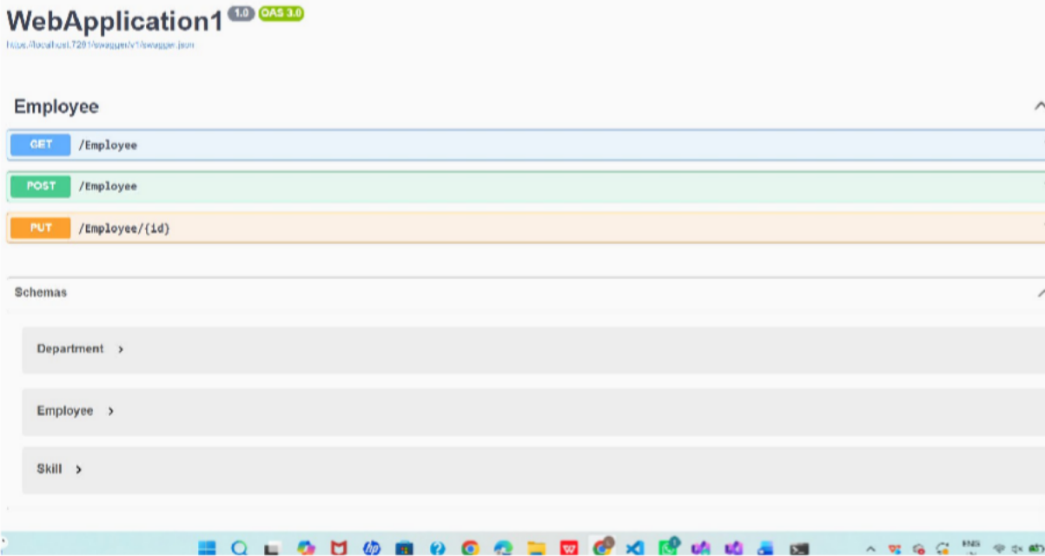
POST METHOD:
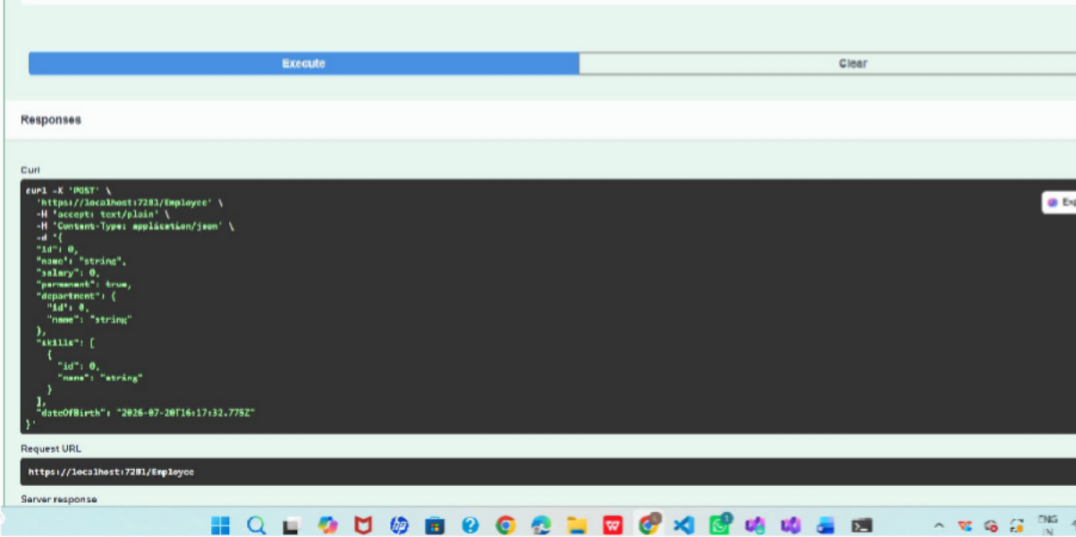
Put:

WEB API MODULE
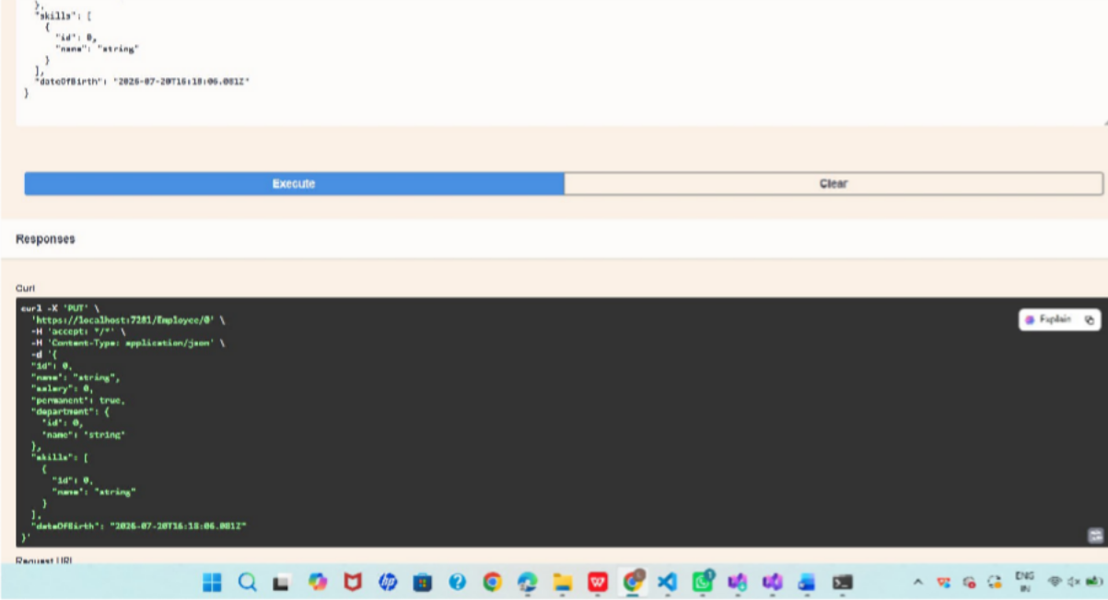
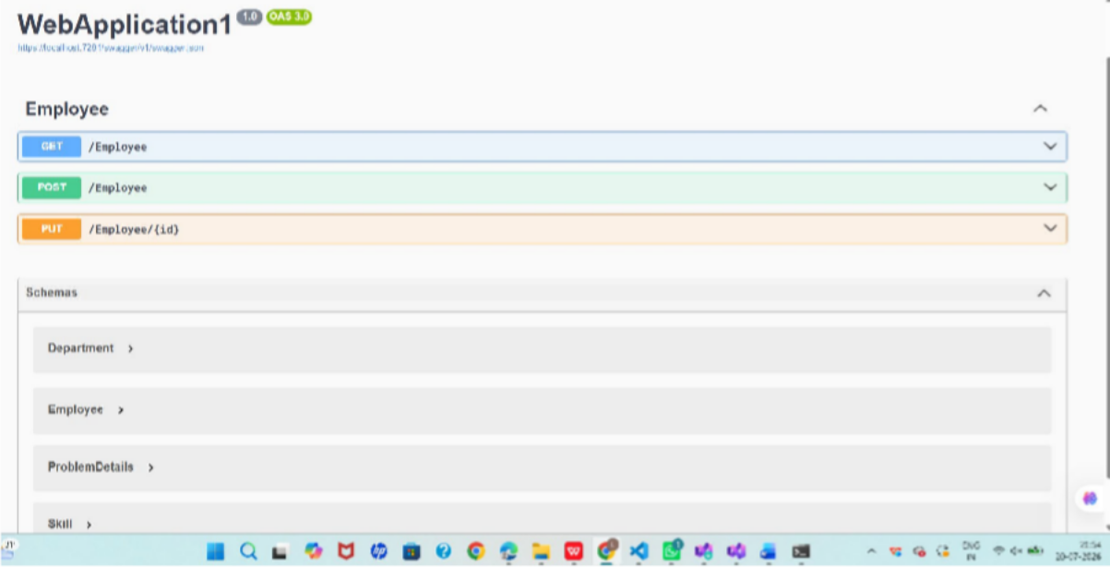

Custom authorization Filter:

WEB API MODULE
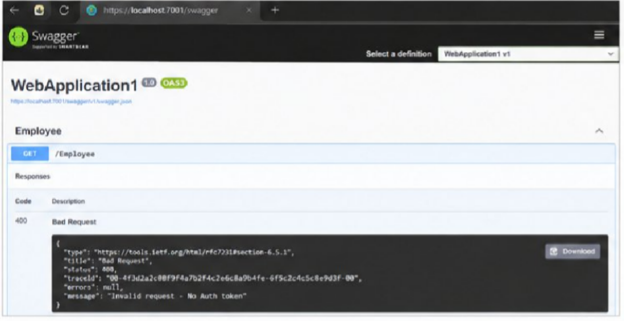
Header present but no barrer:
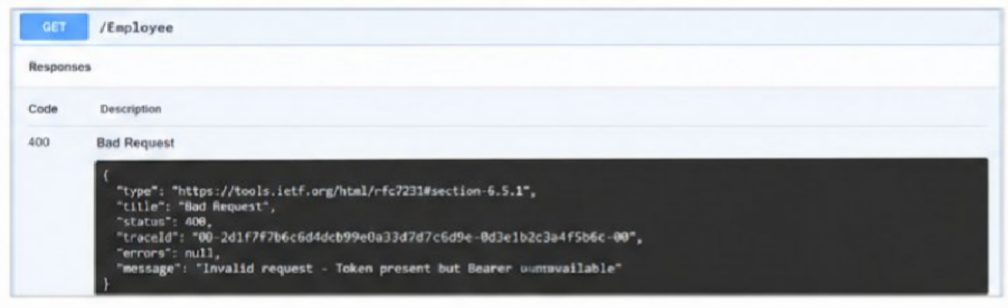
Custom execption filter:

WEB API MODULE
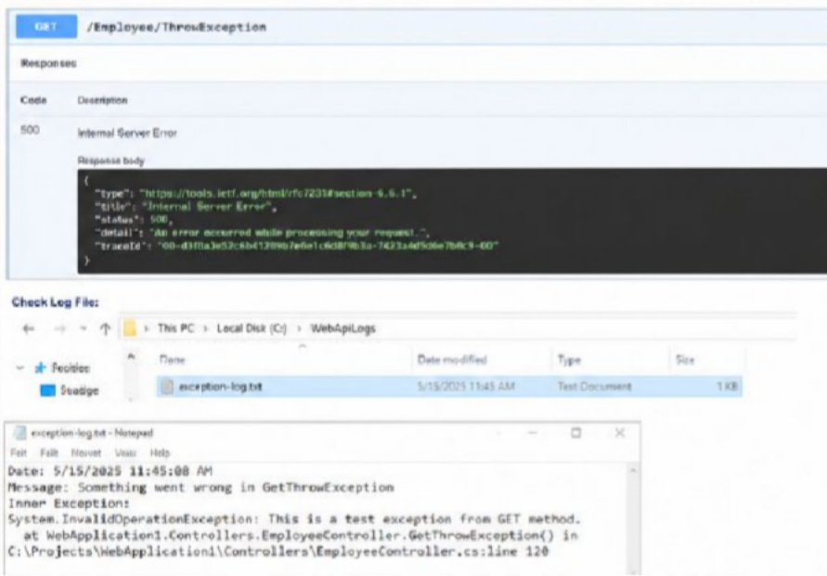
Swagger postman Routing :
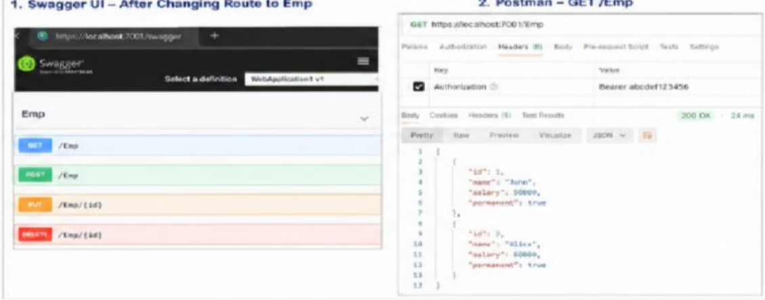

Experiment: CRUD Operations in ASP.NET Core Web API (Update Employee using HTTP PUT)

Aim
To implement CRUD operations in an ASP.NET Core Web API by creating an HTTP PUT action method to update employee data using the FromBody attribute, validate input, and test the API using Swagger and Postman.

Objectives
- Demonstrate creation of an action method to perform Create, Update, and Delete operations.
- Use the FromBody attribute to receive JSON data from the request body.
- Extract request data into a custom Employee model class.
- Use a hardcoded employee list for update and delete operations.
- Validate employee ID before updating.
- Return appropriate ActionResult responses.
- Test the Web API using Swagger and Postman.

Software Requirements
- Windows 10/11
- Visual Studio Code
- ASP.NET Core .NET 8 SDK
- C# Extension
- Swagger UI
- Postman Code :
using Microsoft.AspNetCore.Authorization; using Microsoft.AspNetCore.Mvc;
using JwtSecurityDemo.Models;

namespace JwtSecurityDemo.Controllers
{
/// <summary>
/// EmployeeController - Demonstrates role-based authorization and CRUD operations
/// This controller uses a hardcoded employee list for learning purposes.

/// </summary> [Route("[controller]")] [ApiController] [Authorize(Roles = "Admin")]
public class EmployeeController : ControllerBase
{
private static readonly List<Employee> Employees = new()
{
new Employee
{
EmployeeId = 1, EmployeeName = "John Smith",
Designation = "Senior Developer", Salary = 95000,
Department = "Engineering"
},
new Employee
{
EmployeeId = 2,
EmployeeName = "Sarah Johnson", Designation = "Project Manager", Salary = 85000,
Department = "Management"
},
new Employee
{

EmployeeId = 3,
EmployeeName = "Michael Brown", Designation = "QA Engineer", Salary = 75000,
Department = "Quality Assurance"
},
new Employee
{
EmployeeId = 4, EmployeeName = "Emily Davis",
Designation = "Business Analyst", Salary = 80000,
Department = "Analysis"
},
new Employee
{
EmployeeId = 5,
EmployeeName = "Robert Wilson", Designation = "DevOps Engineer", Salary = 92000,
Department = "Infrastructure"
}
};

[HttpGet]
public ActionResult<IEnumerable<Employee>> GetEmployees()

{
return Ok(new
{
message = "Employee list retrieved successfully", count = Employees.Count,
employees = Employees
});
}

[HttpGet("{id}")]
public ActionResult<Employee> GetEmployeeById(int id)
{
if (id <= 0)
{
return BadRequest(new { message = "Invalid employee id" });
}

var employee = Employees.FirstOrDefault(e => e.EmployeeId == id); if (employee == null)
{
return NotFound(new { message = $"Employee with ID {id} not found" });
}

return Ok(new
{
message = "Employee retrieved successfully",

employee = employee
});
}

[HttpPost]
public ActionResult<Employee> CreateEmployee([FromBody] Employee employee)
{
if (employee == null)
{
return BadRequest(new { message = "Employee data is required" });
}

if (employee.EmployeeId <= 0)
{
return BadRequest(new { message = "EmployeeId must be greater than zero" });
}

if (Employees.Any(e => e.EmployeeId == employee.EmployeeId))
{
return BadRequest(new { message = $"Employee with ID {employee.EmployeeId} already exists" });
}

Employees.Add(employee);

return CreatedAtAction(nameof(GetEmployeeById), new { id = employee.EmployeeId }, new

{
message = "Employee created successfully", employee = employee
});
}

[HttpPut("{id}")]
public ActionResult<Employee> UpdateEmployee(int id, [FromBody] Employee updatedEmployee)
{
if (id <= 0)
{
return BadRequest(new { message = "Invalid employee id" });
}

if (updatedEmployee == null)
{
return BadRequest(new { message = "Employee data is required" });
}

var existingEmployee = Employees.FirstOrDefault(e => e.EmployeeId == id); if (existingEmployee == null)
{
return BadRequest(new { message = "Invalid employee id" });
}

existingEmployee.EmployeeName = updatedEmployee.EmployeeName; existingEmployee.Designation = updatedEmployee.Designation; existingEmployee.Salary = updatedEmployee.Salary; existingEmployee.Department = updatedEmployee.Department;

return Ok(new
{
message = "Employee updated successfully", employee = existingEmployee
});
}

[HttpDelete("{id}")]
public ActionResult<Employee> DeleteEmployee(int id)
{
if (id <= 0)
{
return BadRequest(new { message = "Invalid employee id" });
}

var employee = Employees.FirstOrDefault(e => e.EmployeeId == id); if (employee == null)
{
return BadRequest(new { message = "Invalid employee id" });
}

Employees.Remove(employee);

return Ok(new
{
message = "Employee deleted successfully", employee = employee
});
}
}
}

Output:
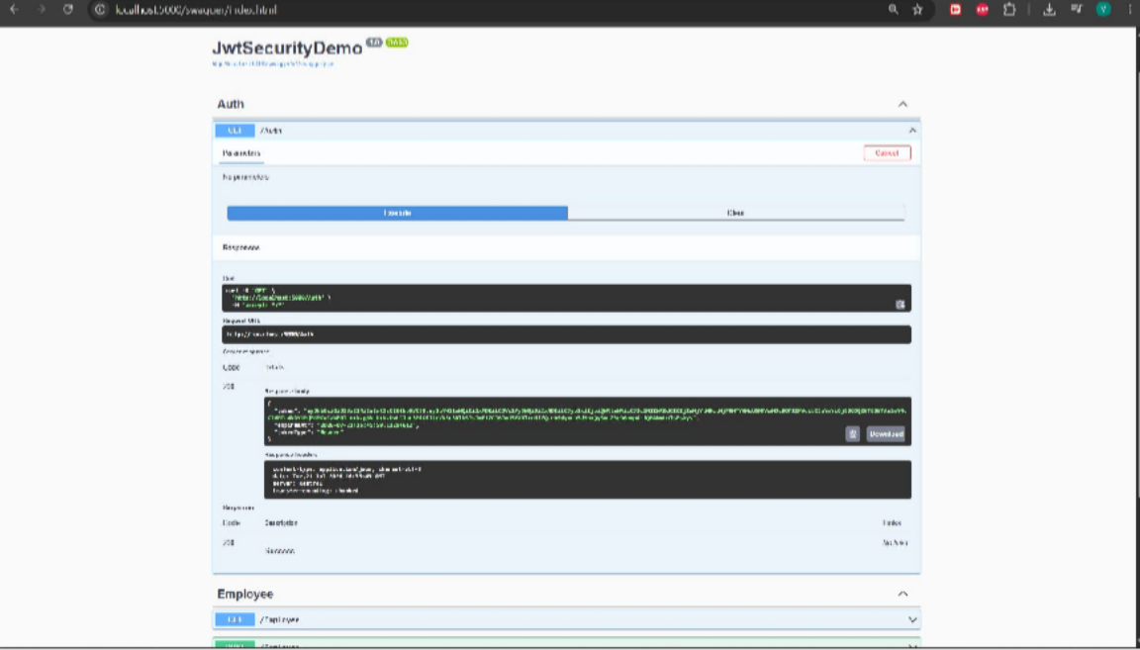

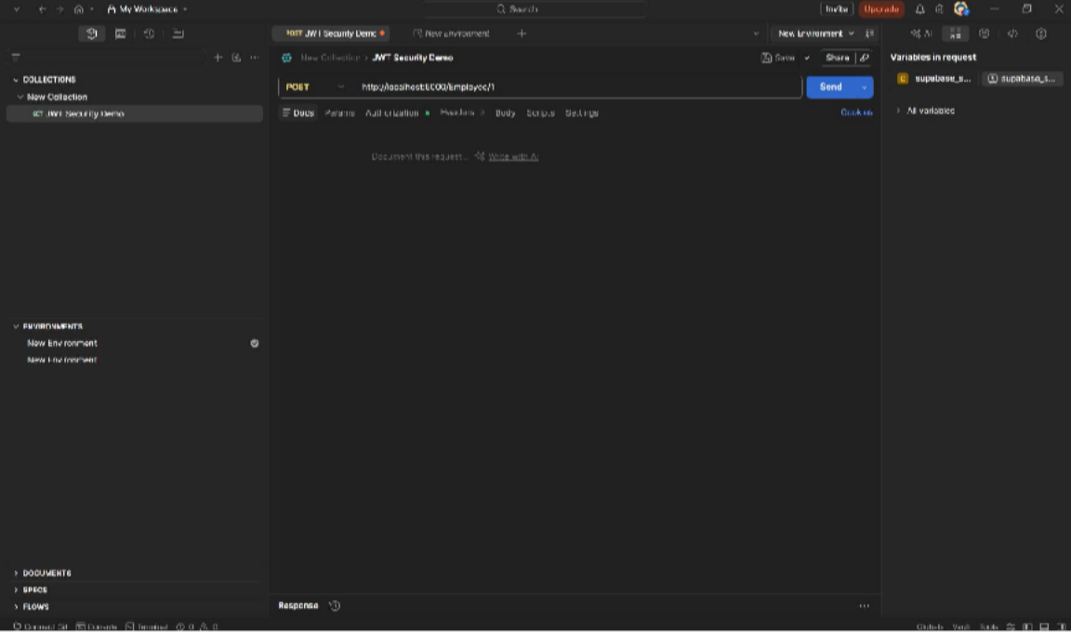

Experiment: CORS Enablement and JWT Authentication in ASP.NET Core Web API

Aim
To implement Cross-Origin Resource Sharing (CORS) and secure an ASP.NET Core Web API using JSON Web Token (JWT) authentication and role-based authorization, and to verify authentication, authorization, and token expiration using Postman.

Software Requirements
- Windows 10/11
- Visual Studio Code
- .NET 8 SDK
- C# Extension for VS Code
- Postman
- Internet connection (for NuGet packages)

Packages Required
- Microsoft.AspNetCore.Authentication.JwtBearer using Microsoft.AspNetCore.Authorization;
using Microsoft.AspNetCore.Mvc; using Microsoft.IdentityModel.Tokens;
using System.IdentityModel.Tokens.Jwt; using System.Security.Claims;
using System.Text;

using JwtSecurityDemo.Models;

namespace JwtSecurityDemo.Controllers

{

[Route("[controller]")] [ApiController] [AllowAnonymous]
public class AuthController : ControllerBase

{

private const string JwtSecret = "S3cureKeyForJWTSigning_ChangeThisToAStrongSecret_0123456789";
private const string JwtIssuer = "mySystem"; private const string JwtAudience = "myUsers"; private const int TokenExpiryMinutes = 10;

[HttpGet]

public IActionResult GenerateToken()

{

try

{

int userId = 101;

string userRole = "Admin";

var token = GenerateJSONWebToken(userId, userRole);

var expiresAt = DateTime.UtcNow.AddMinutes(TokenExpiryMinutes);

return Ok(new TokenResponse

{

Token = token, ExpiresAt = expiresAt, TokenType = "Bearer"
});

}

catch (Exception ex)

{

return BadRequest(new

{

message = "Error generating token", error = ex.Message
});

}

}

private string GenerateJSONWebToken(int userId, string userRole)

{

var key = Encoding.UTF8.GetBytes(JwtSecret);

var signingCredentials = new SigningCredentials( new SymmetricSecurityKey(key), SecurityAlgorithms.HmacSha256);

var claims = new List<Claim>

{

new Claim(ClaimTypes.NameIdentifier, userId.ToString()), new Claim("UserId", userId.ToString()),
new Claim(ClaimTypes.Role, userRole),

new Claim("IssuedAt", DateTime.UtcNow.ToString("o"))

};

var tokenDescriptor = new SecurityTokenDescriptor

{

Subject = new ClaimsIdentity(claims),

Expires = DateTime.UtcNow.AddMinutes(TokenExpiryMinutes), Issuer = JwtIssuer,
Audience = JwtAudience,

SigningCredentials = signingCredentials

};

var tokenHandler = new JwtSecurityTokenHandler();

var token = tokenHandler.CreateToken(tokenDescriptor);

return tokenHandler.WriteToken(token);

}

}

}

Output:
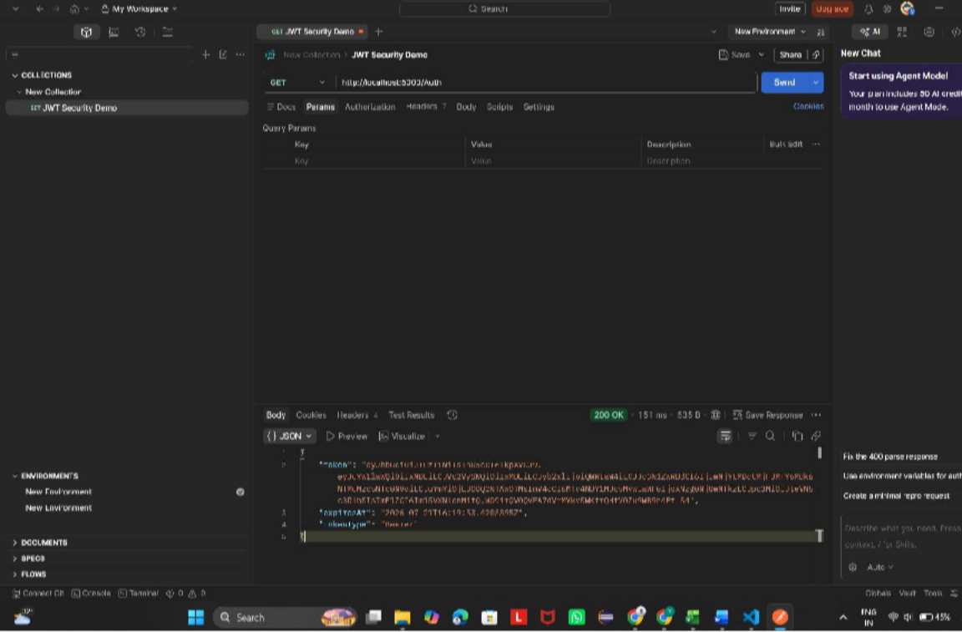

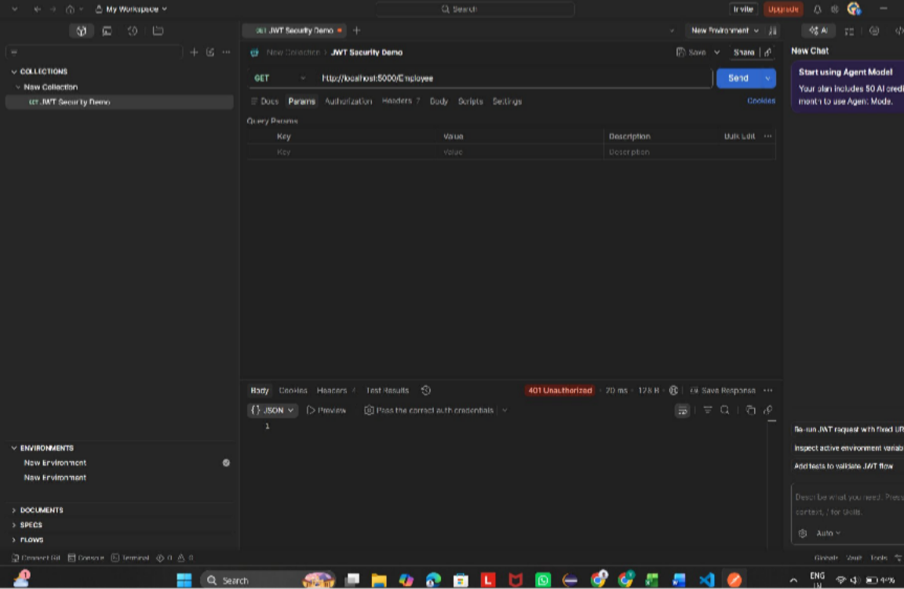

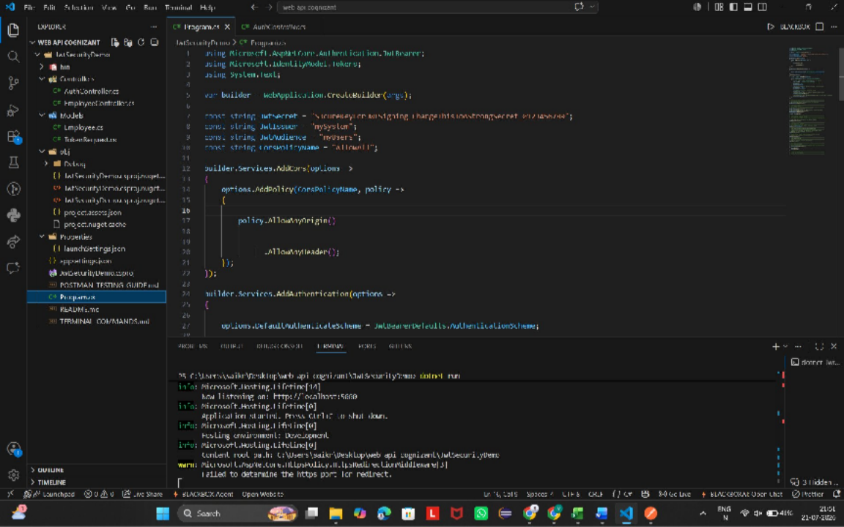

Hands-on 1: Chat Application using Kafka (Command Prompt)

Aim
To develop a C# console chat application that uses Apache Kafka as a message streaming platform to publish and consume chat messages through the Windows Command Prompt.

Software Required
- Windows 10/11
- JDK 17
- Apache Kafka
- Apache ZooKeeper
- .NET SDK 8.0
- Visual Studio Code
- Confluent.Kafka NuGet package

Procedure
- Install Java, Apache Kafka and .NET SDK.
- Start ZooKeeper.
- Start Kafka Server.
- Create a topic named chat-message.
- Create a C# Producer application using Confluent.Kafka.
- Create a C# Consumer application.
- Run producer and consumer in separate command prompts.
- Type messages in producer and verify consumer receives them.

Sample Source Code
// Producer
var config=new ProducerConfig{BootstrapServers="localhost:9092"}; using var producer=new ProducerBuilder<Null,string>(config).Build();
await producer.ProduceAsync("chat-message",new Message<Null,string>{Value="Hello Kafka"});

// Consumer
var c=new ConsumerBuilder<Ignore,string>( new
ConsumerConfig{BootstrapServers="localhost:9092",GroupId="g1",AutoOffsetReset=AutoOffsetReset.E arliest}).Build();
c.Subscribe("chat-message"); Console.WriteLine(c.Consume().Message.Value);
Expected Output Producer Console: Hello Kafka
This is my first message

Consumer Console:
Hello Kafka
This is my first message




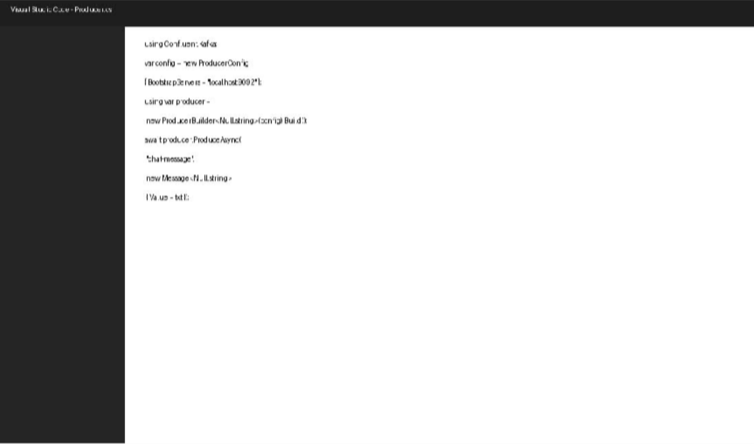

Hands-on 2: C# Windows Chat Application using Kafka

Aim
To create a Windows Forms chat application in C# that exchanges messages between multiple client applications using Apache Kafka.

Software Required
- Windows 10/11
- Visual Studio 2022 / VS Code
- JDK 17
- Apache Kafka
- ZooKeeper
- .NET Windows Forms
- Confluent.Kafka

Procedure
- Create a Windows Forms project.
- Add Confluent.Kafka package.
- Design UI with message textbox, Send button and chat area.
- Implement Kafka producer on Send button.
- Implement background consumer to receive messages.
- Run two instances of the application and exchange messages.

Sample Source Code
// Send button
await producer.ProduceAsync("chat-message",
new Message<Null,string>{Value=txtMessage.Text});

// Receive
var msg=consumer.Consume(); listBox1.Items.Add(msg.Message.Value);

Expected Output
Client 1:
Hi
How are you?

Client 2:
Hi
How are you?
Messages appear instantly in both applications.

Command Prompt Screenshot
The following screenshot was provided by the user showing the Windows Command Prompt environment used for the Kafka setup.

